ECSE 4965/6965

Introduction to Deep Learning

**Program Assignment 3**

Due date: 11:59 pm, April 4th

In this project, you will implement a CNN for CIFAR-10 dataset. The image dataset contains 60k 32x32 color images of objects of 10 classes as shown below.

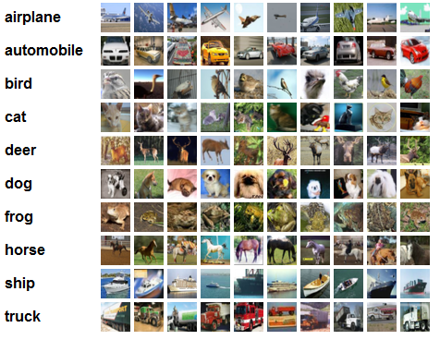

**Figure 1: Sample CIFAR-10 images and their class labels**

Further information on the dataset can be found in <http://www.cs.toronto.edu/~kriz/cifar.html>

See the attached instructions on the architecture of the CNN. You are required to implement the CNN completely using Tensorflow’s native functions to specify the CNN structure and to perform its training. You will be given 50,000 images (5000 images for each class) for training and 5000 images (500 image for each class) for testing. Like previous assignment, we will withhold 5000 images to evaluate your program. Perform the following tasks

1. Give the dimension for each layer, and the number of weight parameters for each convolutional layer and the output layer
2. Implement in Tensorflow the back-propagation method to train the CNN. Initialize weights for all filters for the convolutional layers to small values and iteratively update them ** **with appropriate learning rate until convergence. Plot the training and testing errors for each epoch. Save weights for all layers, as detailed in the attached instructions.
3. Visualize the learnt filters for the first convolution layer (see attached instructions).
4. Given the trained CNN, evaluate its performance on the testing dataset by computing its classification error for each class as well as the average classification errors for all 10 classes.

Submit the following

1. a report that discusses the purpose of this project, your CNN architecture (number of layers, number of filters, filter size, pooling parameters, stride, etc..), hyper-parameters tuning procedure, and plot the training and testing errors over epochs.
2. Visualize the learned filter weights for the first convolutional layer.
3. Show the classification performance in terms of classification accuracy for each class for the testing data.
4. Submit your Tensorflow code and the saved weights **W**.

Further information on the dataset, the architecture of the CNN, and on Tensorflow implementation details can be found in the attached instructions.